Building a community of students that use their powers of observation

to create a record of their natural world.

Project Idea by Laura Schofield, Bartlett Community Partnership School

AS YOU EXPLORE THE OUTDOORS, BE SURE TO MAINTAIN SOCIAL DISTANCING OF SIX FEET.

WASH YOUR HANDS WHEN YOU RETURN HOME.

1. **Choose Option 1 or 2.**

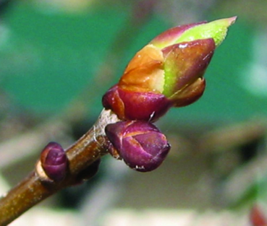**OPTION 1** – Pick a subject listed below to photograph:

* Signs of new life
* Branches with new leaf buds
* Animals with their young
* Sunrise or Sunset
* Moonrise or Moonset
* Wild Turkeys
* Bald Eagle
* 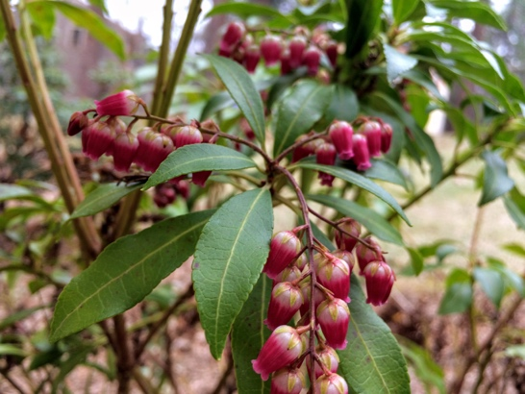Birds feeding
* Rabbits or squirrels gathering food
* Beaver, muskrat or otter swimming
* Squirrels & chipmunks collecting food
* Egg sacks
* Evidence of erosion
* Animal scat (poop)
* Beaver lodge
* Nests

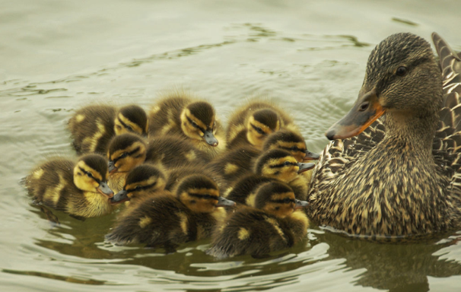

**OPTION 2** – Pick a theme below & create two photographs that embodies that theme

* Capture a pattern in the natural world
* Capture a change in the natural world

1. ****Take your digital photos.** You may use a phone, tablet or digital camera.
2. **Send your photos to your teacher using Google Classroom or whatever electronic platform used by your class. Give your pictures a title.**
3. **Rules**

* Be safe when taking photos
* Take your own photos
* Please no people or pets in photos *(We love them, but the focus is the natural world)*
* Names of students will not be posted with photos